**Lesson 3 Demo 2**

**Sign a Message Using Asymmetric Cryptography**

|  |
| --- |
| **Objective:** To sign a message using asymmetric cryptography  **Tools required:** Ubuntu and Web browser  **Pre-requisites:** None |

Steps to be followed:

1. Signing a message using asymmetric cryptography

**Step 1: Signing a message using asymmetric cryptography**

1. Visit <https://andersbrownworth.com/blockchain/public-private-keys/signatures>
2. Enter the message and click on **Sign** to add a digital signature

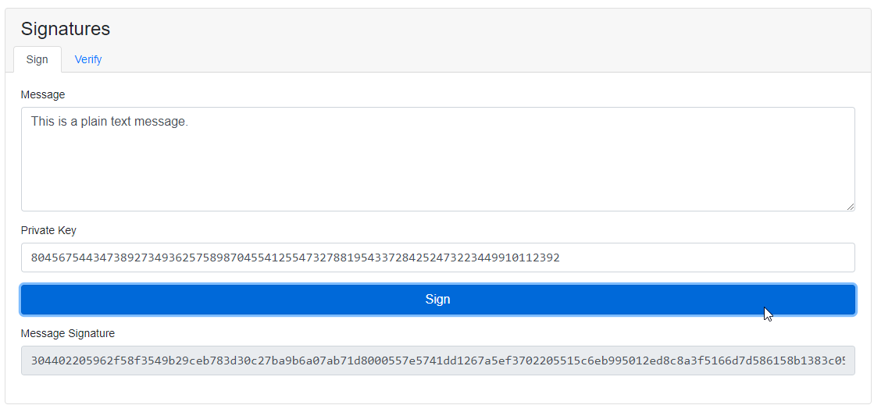

1. Click on the **Verify** tab to verify the signature

The signature is now verified.